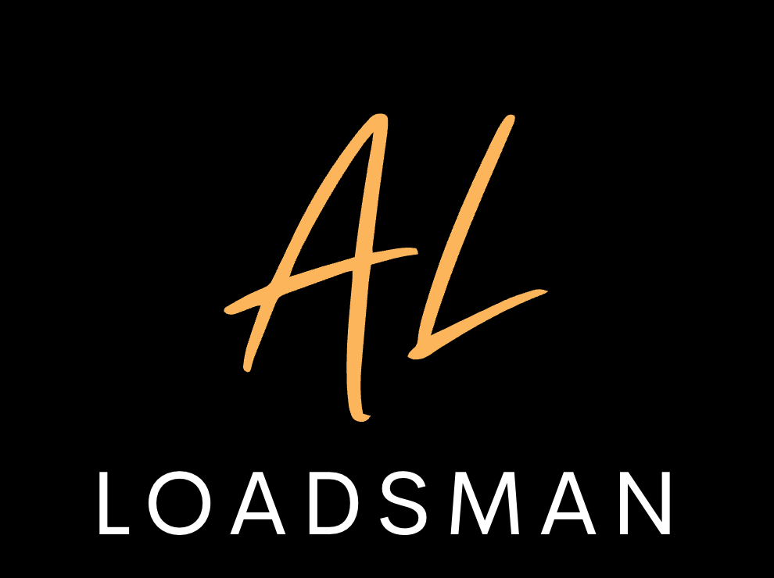

**w:** www.andrewloadsman.com.au

**e:** info@andrewloadsman.com.au

**A.B.N:** 19836857923

10 Thousand Hours - Dan + Shay & JB   
 All Of Me - John Legend  
 All Star - Smash Mouth  
 All Your Love - Flight Facilities  
 Am I Wrong - Nico & Vinz  
 At Last - Etta James  
 All The Small Things - Blink 182  
 Bad Habits- Ed Sheeran  
 Babylon - David Grey  
 Bloom - The Paper Kites  
 Be My Girl - Jet  
 Beautiful Day - U2  
 Black bird - Beatles  
 Black Or White – MJ  
 Brother - Matt Corby  
 Can’t Feel My Face - The WKND  
 Can’t Help Falling In Love - Elvis  
 Counting Stars - One Republic  
 Crash - Dave Mathews  
 Cinema - Benny Benassi  
 Crazy - Gnarls Barkley  
 Crying Shame – Diesel  
 Dancing On My Own - Callum Scott  
 Dammit - Blink 182  
 Dance Monkey - Tones & I  
 Every Little Thing She Does - Police (slow)  
 Fall At Your Feet - Boy & Bear Version  
 Feeding Line - Boy & Bear  
 Feel So Close - Calvin Harris  
 Free Fallin’ - Tom Petty  
 Feels Like Home - Train  
 Fire & The Flood - Vance Joy  
 Fly Me To The Moon  
 Follow the Sun – Xavier Rudd  
 Forever - Chris Brown  
 Funky Music  
 Gold On The Ceiling - Black Keys  
 Here Comes The Sun - Beatles  
 Ho Hey – Lumineers  
  
  
  
  
 Horses - Daryl Braithwaite  
 Hold Back The River - James Bay  
 Hound Dog - Elvis  
 Hold My Girl - George Ezra  
 Hurt Somebody - Noah Kahan  
 I Will Wait - Mumford & Sons  
 If I Ain’t Got you - Alicia Keys  
 Isn’t She Lovely - Stevie Wonder  
 I’m Yours - Jason Mraz  
 I wanna Dance With Somebody  
 Lonely Boy - Black Keys  
 Love Runs Out - One Republic  
 Love Somebody Like You - Keith Urban  
 Love Someone – Lukas Graham  
 Latch - Sam Smith  
 Love Your Self - JB  
 Love Your Way - Powder Finger  
 Lover Lover - Sonia Dada  
 Mr Brightside- Killers  
 Never Tear Us Apart - INXS  
 On My Mind - Powder Finger  
 Only Love - Ben Howard  
 Perfect - Ed Sheeran  
 Piece Of Your Heart  
 Pompeii - Bastille  
 Praise You - Fat Boy Slim  
 Resolution - Matt Corby  
 Riptide - Vance Joy  
 River - Leon Bridges  
 Save Tonight - Eagle Eye Cherry  
 Say You Won’t Let Go – James Arthur  
 Sweet Caroline - Neil Dimond  
 Seven Nation Army - White Stripes  
 Shape Of You – Ed  
 Simple Things - Ziggy Alberts  
 Skinny Love - Birdy  
 Small Things - Blink 182  
 Something I Need - One Republic  
 Something Just Like this – C. Smokers  
 Stand By Me  
 Superstition  
 Sugar - Robin Schulz  
 Sweet Child Of Mine - Guns & Roses  
 There’s Nothing Holding Me Back – Shawn  
 These Days - Powder Finger  
 Thinking Out Loud - Ed Sheeran  
 This Year’s Love - David Grey  
 Truly Madly Deeply - Savage Garden  
 Time Of Your Life - Green Day  
 Uptown Funk - Bruno  
 Use Somebody - Kings Of Leon  
 Valerie - Amy Wine House  
 Vertigo - U2  
 Waiting On The World To Change – JM  
 Wake Me Up - Avicii  
 Watermelon Sugar – Harry Stylez  
 With Or Without You - U2  
 When I come Around - Green Day  
 Won’t Let You Go - James Morrison  
 Wonder Wall - Oasis  
 XO - John Mayer  
 Yellow - Cold Play  
 You Are The Reason - Callum Scott  
 You & Me - Life House  
 You Found Me - The Fray  
 You’re The Voice - John Farnham